**Importing an Image & Viewing it**

import cv2  
image = cv2.imread("./Path/To/Image.extension")  
cv2.imshow("Image", image)  
cv2.waitKey(0)  
cv2.destroyAllWindows()

**Warning 1:** On reading images this way via openCV, it isn’t in ***RGB*** colorspace—it’s in ***BGR***. Sometime this won’t be an issue with you, **you’ll only have trouble if you want to add something colored to your image.**There are two solutions:

1. Switch the ***R — 1st one***(red) with the ***B — 3rd one***(blue), so that Red is *(****0****,0,****255****)* instead of *(****255****,0,****0****)*.
2. Change the colorspace to **RGB**:

rgb_image = cv2.cvtColor(image, cv2.COLOR_BGR2RGB)

and go on with your code with rgb_image instead of image*.*

**Warning 2:** To close the window that’s displaying the image, press any button. **If you use the close button it may cause freezes** (happens to me when I’m on a Jupyter notebook).

For simplicity, throughout this tutorial I’ll be using this method to view images:

import cv2  
def viewImage(image, name_of_window):  
 cv2.namedWindow(name_of_window, cv2.WINDOW_NORMAL)  
 cv2.imshow(name_of_window, image)  
 cv2.waitKey(0)  
 cv2.destroyAllWindows()

Image for post

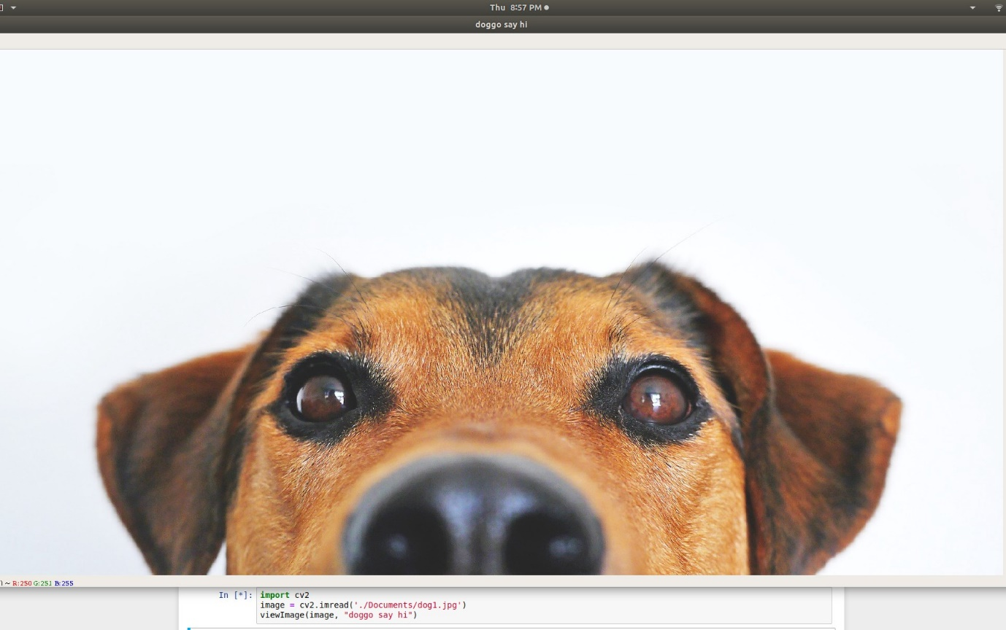

Source: [Pixabay](http://pixabay.com)

**Cropping**

Image for post

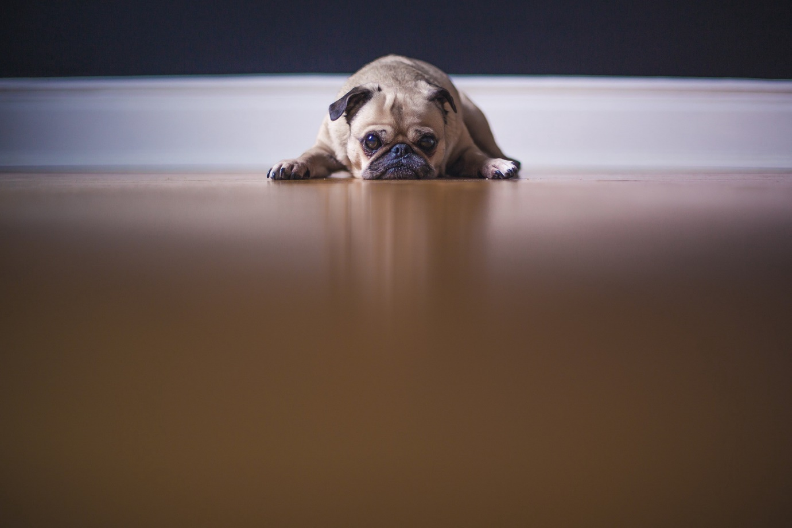

Source: Pixabay

Image for post

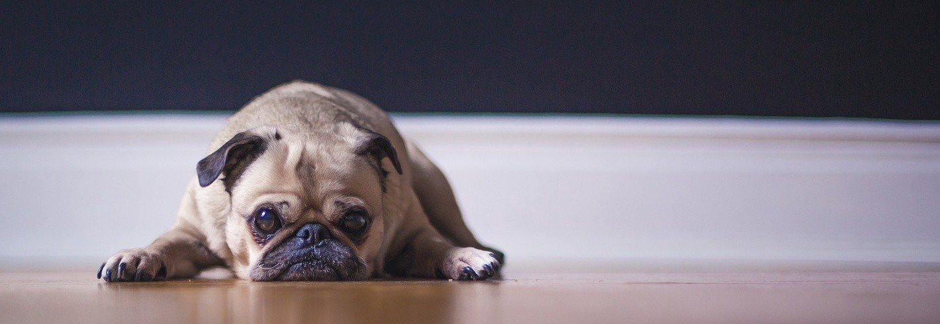

Doggo after cropping.

import cv2  
cropped = image[10:500, 500:2000]  
viewImage(cropped, "Doggo after cropping.")

where image[10:500, 500:2000]isimage[y:y+h, x:x+w]

**Resizing**

Image for post

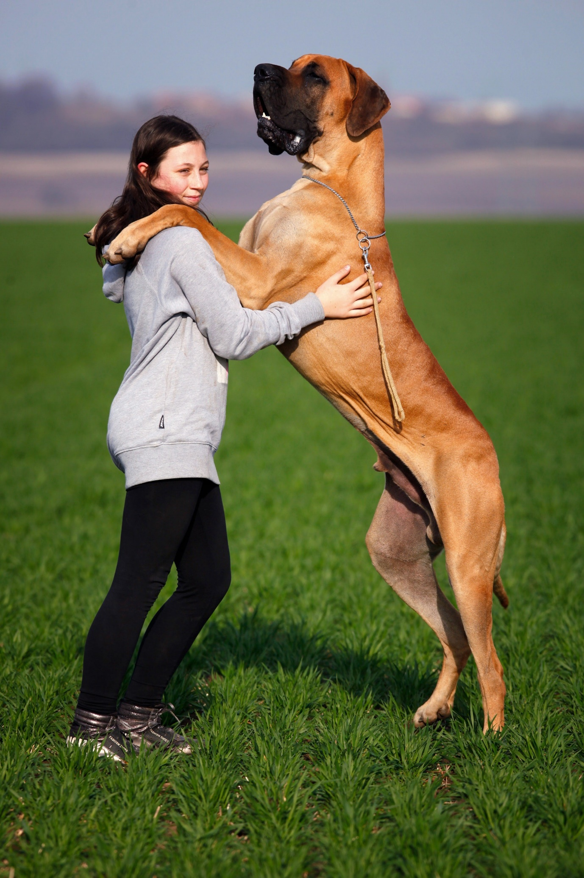

Source: [Pexels](http://pexels.com)

Image for post

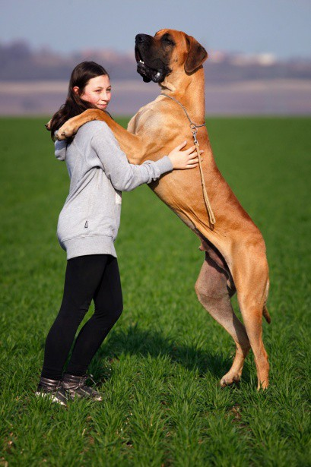

After resizing with 20%

import cv2  
scale_percent = 20 # percent of original size  
width = int(img.shape[1] * scale_percent / 100)  
height = int(img.shape[0] * scale_percent / 100)  
dim = (width, height)resized = cv2.resize(img, dim, interpolation = cv2.INTER_AREA)viewImage(resized, "After resizing with 20%")

This resizing function maintains the dimension-ratio of the original image.

*More image scaling functions* [*here*](https://www.tutorialkart.com/opencv/python/opencv-python-resize-image/)*.*

**Rotating**

Image for post

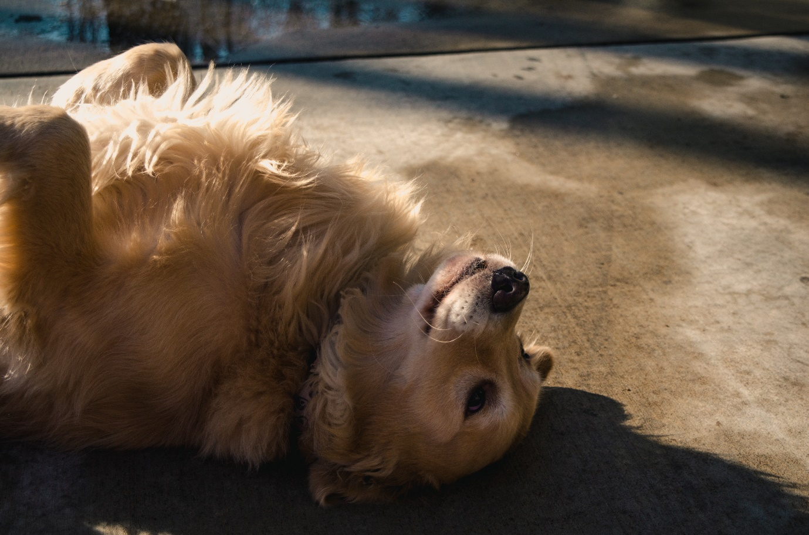

Image for post

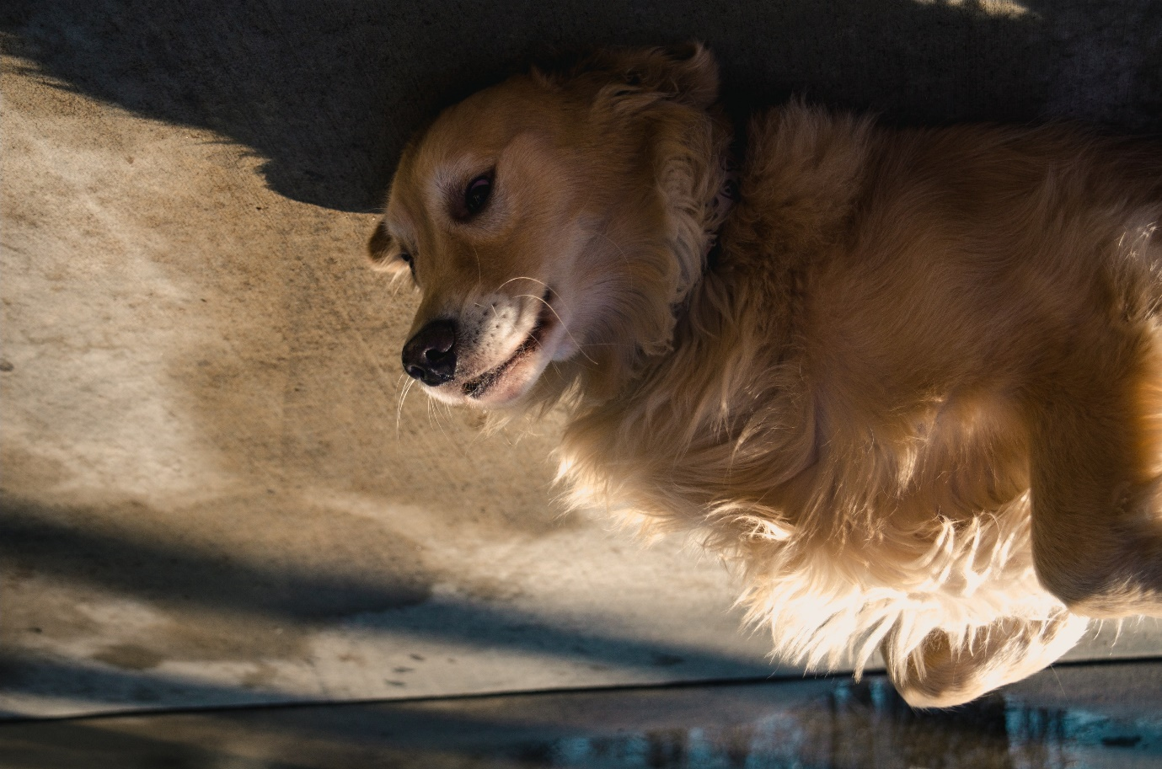

Left: Photo by Jonathan Meyer from [Pexels](http://pexels.com). Right: Doggo after rotation by 180 degrees.

import cv2  
(h, w, d) = image.shape  
center = (w // 2, h // 2)  
M = cv2.getRotationMatrix2D(center, 180, 1.0)  
rotated = cv2.warpAffine(image, M, (w, h))  
viewImage(rotated, "Doggo after rotation by 190 degrees")

image.shape outputs the height, width, and channels. M is the rotation matrix—this rotates the image 180 degrees around its center.  
-ve angle rotates the image clockwise & +ve angle rotates the image counterclockwise.